Fediverse/MetaNet spec sheet

Github - https://github.com/NodeFederation
Element Chat - https://app.element.io/#/room/#fede:matrix.org

Meeting Videos
- Full Team Meetings
  - 4/20/2021
  - 4/27/2021
  - 5/7/2021
- Node Installer Meetings
  - 5/1/2021

Developers
- Ian Crossland - ian@iancrossland.net
  - Front-End design, Minds co-founder
- Andreas Xirtus - i@xirt.us
- Ben Nathaniel - ben@timcast.com
  - Cloud architect
  - Drupal
  - Kubernetes
  - specializes in: Databases & Storage
  - self-taught software eng.
  - B.Sc in Finance
- Kade Green
  - Sr Software engineer / Architect (FOX)
  - 8 years of Video Streaming Experience
  - Golang, Nodejs, Python, some php
  - Entrepreneur
  - Kadebom.com
  - kadesgreen@gmail.com
  - github.com @luckybroman5
- James Christensen - JayCeeJr@github, james@minsys.net
  - Full Stack - Primarily Angular / Django
  - CI/CD - Jenkins / Drone / Vela
  - Docker Kubernetes
  - Postgres
  - 20+ years Linux
  - Wowza Livestreaming
- Stephen Dollinger - soundwavetm2
  - Solution architect
    - Route/Switch
      - Enterprise
      - Service Provider
    - DataCenter
      - Rack servers
      - Blade Servers
      - Virtualization
      - Automation
    - CDN
    - Cloud
      - Delivery
      - Micro Transactions
      - Analytics
    - Security
      - Planing, Designing and implementation
    - Voice/Video
      - Cisco Telepresence
      - Expressway
      - CUCM and CUC
      - UCCE
      - CVP
      - Hybrid Calling
      - CER
      - CUSP
    - Service Provider Routing Switching
      - 10G/40G/100G Configured and setup for CDN networks
  - Load Testing with multiple tools
  - QA testing
  - BS Information Technology -2010
  - MS Information Security - 2022
  - Certifications
    - CCIE Voice
    - CCIE Routing and Switching
    - CCNP Cloud
    - VCP
    - JNCP
    - Cisco Devnet

- Phillip Fisher | phillipfisher@gmail.com
  - Full Stack / Backend Engineer / Mobile Apps
    - Mainly C# / .NET
  - Low Level TCP/UDP Communications
  - Security
  - Cloud Infrastructure
  - Payment / Banking Background

- TJ Phippen - siforek | tjphippen@github | tj@tjphippen.com
  - Full Stack / Backend Engineer
    - PHP(Laravel), SQL, AMQP, SASS/CSS, JS, NGINX, React, Vue, Ionicframework, WebRTC,
    - REST APIs, micro services & 3rd party integrations.
  - Build racing/freestyle drones, arduino/PI gadgets
  - Crypto mining, automated algo switching scripts, masternodes/setup scripts
  - Musician/audio engineering, video editing,
- Alfie Coulson
  - Full stack but please don’t get me to do any CSS
  - .net/.netcore, react, python, C++, SQL, graph dbs, angular, azure
- Calvin Holloway
  - Founder (and solo dev): www.goodkarma.ai
  - Full Stack
  - Flutter (mobile), GCP/AWS, JS, Go, K8s, WP
- NNKC - Tom - newsnowkansascity@gmail.com
  - Backend large scale systems distributed globally
  - Golang, Python, JS, Java, Ruby, .Net, Scala, SQL
  - BS, MS Computer Science/Data Science Illinois
  - AWS, GCloud, Hadoop, Tensorflow, Kafka, Storm, Jenkins (lol), k8s, Cassandra
  - DevOps Engineer, Chief Architect, Software Engineer, Product Manager
  - Android Development
  - Complex Systems and Safety Science interest me
- Ted Dotard - DotardTed@gmail.com
  - Routing: Cisco, Brocade, Extreme, Juniper VPN, Arista
  - VoIP Avaya, Cisco, Shoretel
  - IDS/IPS/NAC SPLUNK, SPL, SolarWinds, Nagios
  - Linux / Windows / VMWare servers
  - Linux, Apache, MySQL and PHP (LAMP) Puppet
  - Cisco ASA, Check Point and Palo Alto firewalls;
  - Scripting: Python, BASH, Perl, Powershell, etc.
  - Load balancers F5 LTM GTM/DNS/APM, Citrix NetScaler, RoundRobin DNS
  - Storage EMC, NetApp, Hitachi, Seagate
  - Governance: MICS, PCI, SOX, +FERPA, HIPAA
- Phil Romov - QuakePhil@github
  - Been hooked on coding (with slant on r&d/skunkworks) after discovering QBasic in jr high ~25 years ago
  - 20+ years: PHP, JS, SQL, HTML/CSS
  - 10+ years: Python, Ruby, VBA, COBOL
  - 5+ years: C, Perl, Java, AWS, Docker
  - Learning: Go, HCL
  - More details: https://quakephil.github.io/
  - Have worked on frontend as long as backend, but more interested in backend
  - Most recent interest coding big data processors using awslabs datawrangler package
- John Miller - https://gitlab.com/Zakki_Orichalcum
  - Full Stack
  - .net/.net Core, Vuejs, JS, Nodejs, SQL, Python, Java
  - Decent amount of Jenkins and TeamCity experience as DevOps

- Evanilson Abril - https://github.com/vbspace (evanilsondev@gmail.com)
  - Full Stack
  - Java, C, Javascript, NodeJS, MongoDB
  - Docker, Jenkins, CodePush, Bash, Perl and AWK
  - AWS and GCP
- Jerry Jäppinen: https://github.com/jerryjappinen (jerryjappinen@lateralnord.com)
  - UX/Service design
  - Content management
  - Node.js, frontend (Vue.js), Prisma
  - Modern cloud services (Contentful, Vercel, Netlify, Heroku...)
- Michael McDonagh - mikemcdonagh@protonmail.com
  - https://mcdonagh.dev
  - https://github.com/m-mcdonagh
  - Full Stack
  - C, C#, Java, JavaScript, TypeScript, Python, Bash, Go
  - ASP.NET, Node.js, Spring Boot
- Bashar Jaan Khan basharjaankhan@gmail.com
https://github.com/thisHermit
  - Full Stack
  - Java, C, JavaScript, Python
  - Docker, Bash
  - AWS and GCP
- Stephen Nilsen - stevenilsen@live.com
  - Full stack but mostly love front-end
  - Specialize in Android
  - Java / Kotlin / Python
  - Docker / Kubernetes / Azure
  - Also love UI design / user experience / animations
  - linkedin.com/in/stephennilsen

- Andrei Tuculescu - andrei.tuculescu@gmail.com
  - Back end Python
  - Flask framework
  - Experience with web scraping / automation
  - HTML/CSS/some JS (please don’t make me)
  - Database design
- Sean Morris - Sean@SeanMorr.is
  - Back end PHP
  - Front end JS (ES6)
  - Some WASM (C)
  - Strong knowledge of relational database design, application profiling and optimization of frontend and backend code
  - WebSockets & WebRTP
  - AWS, Docker, Heroku, & Cloudflare
  - Self taught, High school dropout / 14 years full time in the industry
- Ryan Glover - me@ryanglover.net
  - Full-stack JavaScript (JavaScript, TypeScript, Node.js) - ES5-2020+
  - Experience with building front-end and back-end JavaScript platforms (see: https://cheatcode.co).
  - Experience with large application architecture.
  - Experience with building real-time systems via Websockets/OBS
  - Experience with AWS, Kubernetes, Digital Ocean, etc.
  - UI designer with heavy focus on application UI
- Austin Walters - austin@agw.io
  - Full-Stack & ML Engineer: Python, Ruby (Rails), Javascript, Postgresql
  - Professionally: Engineering manager in applied research & startup founder
  - Resume Link, Github Link, Website link
- Jon Sparks - jon@jonsparks.com
  - Platform Engineer
  - PHP / Node.js / SQL
  - Kubernetes / Docker
  - AWS / GCP
  - CI/CD - Github Actions/ Drone
- Rachel Campbell - rachel@relizabeth.com
  - Full Stack Web Developer
  - Web Designer
  - UI/UX
  - React, React Native, ES6
- VOIP - Asterisk
- Eivar Montenegro - e.mont01@gmail.com
  - Full stack developer
  - Backend PHP, Java, Python, Node.js and C#
  - Frontend: vue.js, react & HTML+CSS
  - Containers: Docker, docker-compose
  - GNU/Linux management
  - CI/CD - A little with GitLab pipelines
- Kev Porter - kev@themapps.com
  - Full stack - primarily PHP / Javascript (vanilla and many frameworks/libs of each)
  - Linux
  - Decades of experience, see themapps.com for more skills
- David Doran - davidwdoran@gmail.com
  - https://github.com/ddoran1
  - Frontend: HTML, vue.js, JavaFX
  - Backend: Java, C, Python, Restful
  - Selenium Automation (Java)
  - QAA
- Alex Haussmann Backend Developer PHP python C like Languages some experience with cryptography
Product
- Cory Bowman (Currently a Senior Product Manager and Practice Lead) - corybowman1@protonmail.com
  - Product Management - Lean/Agile but can work however
    - Roadmapping
    - Backlog management
    - Stakeholder management
    - Facilitation
    - Knowledge management
    - Basic branding/marketing
    - Basically all the stuff OTHER than building the darn thing
  - User/Customer Research - most familiar with User Centered Design
  - Passing UX design (Mostly Figma)
  - Abysmal dev capabilities but understand path to prod
- Kade Green
  - Software engineer/architect
  - entrepreneur
  - 8 years of Video streaming experience.
  - kadesgreen@gmail.com

Dev Tools
- MonoRail - wiki
- GitHub: primary
- GitGogs: local mirror
- Vagrant: dev &, test nodes

Trello / Kanban board:

Consider prioritizing Paid dev tools - that are worth the money.
- ex. Asana

Teams
Put your name under the team that you want to be a part of. Also put your element name if it is different than your actual name.
- Installer/Manager/Front-End - Ease of Use
  - Stephen Nilsen

  - Phillip Fisher - architecture, developer
  - Ryan Glover
  - QuakePhil
  - TJ Phippen
  - Bashar Jaan Khan
  - Rachel Campbell (relizabet)
  - Stephen Dollinger
  - Kev Porter (@twosheds:matrix.org)
  - Kade Green (kadesgreen@gmail.com)
- RSS 3.0
  - Ryan Glover
  - Bashar Jaan Khan
  - Eivar Montenegro (emont01)
  - Michael McDonagh
  - Kade
  - James (JayCeeJr)
  - Austin Walters (lettergram)
- Bullet Proof (pentest, anti-deplatforming, etc) Is this really "Pen Testing" or allowing for not being deplatformed?
  - Kade Green
  - QuakePhil
  - Michael McDonagh
  - Andrei Tuculescu
  - Evanilson Braulio
- Distributed Storage/Serverless
  - Ben Nathaniel
  - Evanilson Braulio
  - QuakePhil
  - Stephen Dollinger
  - Andrei Tuculescu
  - Kade Green
  - Austin Walters (lettergram)
- Share the Wealth (NFTs, etc)
  - Rachel Campbell (relizabet)
  - QuakePhil
- Business/domain/product/user research?
  - Stephen Dollinger
  - Rachel Campbell (relizabet)
  - James (JayCeeJr)
  - Cory Bowman
  - Austin Walters (lettergram)

The Creator’s Delivery Dilemma
- Users demand rich content on user friendly interface
- Content creators want to distribute their content with as little effort as possible
- Huge platforms are available that make it very simple for creator but at the cost of autonomy
- Autonomy is hard because a creator normally can’t afford to develop their own platform
- Which do you choose as a creator?

Problem Statement
Content creators face the creator’s delivery dilemma everyday. And because there isn’t an easy solution for the average creator to launch their own platform the open source community loses everyday to the large tech platforms. The way forward to a free and open community is to solve the creator’s delivery dilemma.

Solution Statement
We will provide a very simple to set up, use, manage, backup and redeploy solution that is also user friendly and is palatable to the modern digital consumer. The content creator will be able to quickly configure the platform with no technical knowledge. Then deploy it easily with limited technical expertise. Management will be as straight-forward as any other platform. Backups will be simple and automatic. And the whole site will be redeployable from a single backup on a new server (once again with limited technical knowledge), virtually eliminating the consequences of deplatforming. We will build it in such a way as to allow it to slowly expand its capabilities over time while still keeping the ease of its use paramount.

MVP Goals - Subscription service style site
- User authentication and authorization
- Payment processing / attestation
- Ability to post and have comments
- Paywall
- Mobile App

Installer Phases
- Phase I - Individual Websites
  - Individual creators can create their own independent sites
- Phase II - Mobile
  - Installer deploys website and mobile apps
- Phase III - Federation
  - Creators have the ability to add the “federation module” to their sites
    - Users benefit by content discovery
    - Creators benefit by getting a “finder’s fee”
- Phase IV - MetaNet Hosting
  - Hosting offered by MetaNet

Technology stack(s)
- https://podnews.net/podcast/pi920666
- https://boinc.berkeley.edu/
- https://en.wikipedia.org/wiki/Sun-Ni_law
- https://www.envoyproxy.io
  - https://youtu.be/J9AYpmw8E7A
- https://awesomeopensource.com/project/gdamdam/awesome-decentralized-web
- https://www.arweave.org/
- https://bondlyfinance.medium.com/bondly-and-chainlink-work-together-to-build-a-new-digital-economy-ecd41c682b02
- https://skale.network/
- https://filecoin.io/
- https://ipfs.io/
- https://www.okd.io/
- https://thetacoin.io/
https://github.com/lbryio/chainquery

Github Repos
- https://github.com/tartaria-nova/RSS-3.0
- https://github.com/tjphippen/fediverse

Alternate Techs
- Mastodon
- Dendrite
- Danube Cloud
- Diaspora
- Pixelfed
- Peertube
- Activity Pub
- cPanel
  - Wordpress
- Metamask
- OKD
  - Kubernetes
- Oauth2 for authentication
- https://www.keycloak.org/
- https://aragon.org/
- https://radicle.xyz/
- https://gogs.io/

Platforms
https://podcastindex.org/apps
More:
- https://en.wikipedia.org/wiki/Comparison_of_DNS_blacklists

Element Pinecone
https://fosdem.org/2021/schedule/event/matrix_pinecones/

Connections

Matrix <-> Activity Pub

Resources

Blacklist
https://en.wikipedia.org/wiki/Domain_Name_System-based_Blackhole_List

Paypal Alternatives
- https://www.giveforms.com/
- Anonymized Tether like wallets which can be funded by any source https://tether.to/

Examples

- https://flipboard.com/ aggregator

To install for our Element Matrix Instance

- Jibri for Recording jitsi video conferences to odyssey or youtube
https://github.com/jitsi/jibri
501.c delaware
https://www.harborcompliance.com/information/how-to-start-a-non-profit-organization-in-delaware

https://www.swyftfilings.com/learning-center/best-states-to-start-nonprofit

UniQery
A Php or JVM daemon that lets you securely query resources from one site to another. Speaks Database query languages like SQL & CQL & Object languages like Swift /S3. Formats the data for display on the requesting site. Built on Symfony framework & Spring Boot.

Meeting Minutes:

Meeting 2 (4/20/21)
Action Items:
- Set up product space (artifact/knowledge storage)
- Solidify Persona drafts
- Solidify User Journeys
- Maybe establish teams
- Generate agenda for next meeting
- Get teams set up
- Get chat rooms set up

Assumptions/risks/questions

- Will users leverage Stripe/Paypal or is crypto required to get use
- Assumption: There is a viable solution so simple that any ‘mommy blogger’ can understand
- Assumption: There is some way to bring an audience over…
- Assumption: we just need to bring the creators and there are many that already want to leave YT
- Assumption: creators will bring users
- Assumption: we can create something cheaper and other SASSes will step in to compete
- Question: who manages content tagging? How does it stay true? How can we save it from getting hijacked?
- Assumptions: Minds wants to get involved however possible

Product artifacts (mostly in order)
- User Personas
- User journey(s)
- Problem Statement
- Business Model Canvas / Value Proposition
- Scope
- Vision
- Strategy
- MVP Hypothesis
- Roadmap
- Tech decisions
- Prototypes
- Backlog

What does it look like done?
- Decentralized Patreon?
- Going to aggregate all these markets into the form to get your content out there
- Friends list, followers list, EGPRM paywall, hash tagging/tagging.. Replaces all of it really
- Build the uniformed standard
- We aren’t hosting, we are providing the tools for the creator to control the 100% of it
- There are competitors to patreon and they aren’t talking, we are going to make them talk
- Creating a marketplace for businesses that already exist
- Set up to find the cheapest solution for hosting, payment, distro etc so creators can make the best decision
- Whereas Patron takes a cut, our service would take no cut
- People can have their own TimCast without having to hire devs to build it

Top Priorities (needs to be prioritized)
- Has to be simple
- Has to have low barrier to entry

Personas:

Tim the established creator.
- Objectives: Create High quality content, and expand the audience
- Knowledge Level: High
- Turn offs: Getting demonetized
- Priority: High

Becky the mommy blogger.
- Objectives: Share knowledge as a hobby, influence some people
- Knowledge Level: Low
- Turn offs: Having to spent time setting up technology, it should just work
- Priority: Low (Hobby)

Joe the consumer.
- Objectives: Find content he is interested in and get suggestions on other content.
- Knowledge Level: Medium
- Turn offs: Bad content / mainstream media
- Priority: Medium

Timcast the Creator Network.
- Objectives: Create a network of creators, with sitcoms, talk shows, news and other content. And pay the creators.
- Knowledge Level: High
- Turn offs: Getting demonetized / canceled
- Priority: High

Localized, the established social network:
- Objectives: Federate with the fediverse, use integration with the fediverse to gain customers
- Knowledge Level: High
- Turn offs: Losing users because of censorship
- Priority: High

Personas - User Stories:
Have a few by country, which may have different customs & problems.

Feature Ideas (need validation and prioritization)
Search Engine:
3 components:
- Search Index (database)
- Spidering and sorting processes (compute, map-reduce)
- Algorithms & maps (functions)
The Search Index is a global public shared resource and spiders all content in the network.
Algorithms are fully customizable and shareable: Individual Site owners / Publishers install a package of Algorithms specific to their niche & configure search parameters, filters, and tags to only show content they want.
Recommendation System:
Optional site blocks, like a sidebar sidebar and autoplayed recommended videos, based uses the search engine API to retrieve results.

General Architecture (Proposed)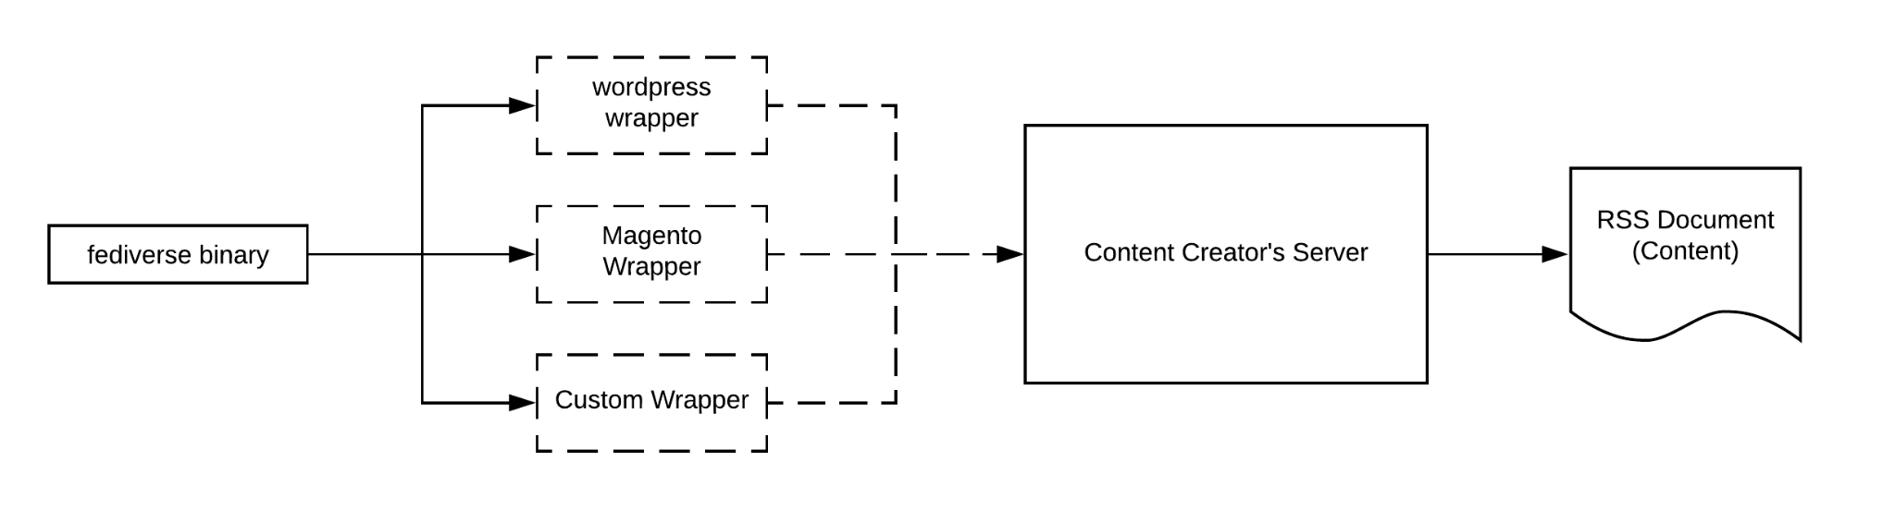
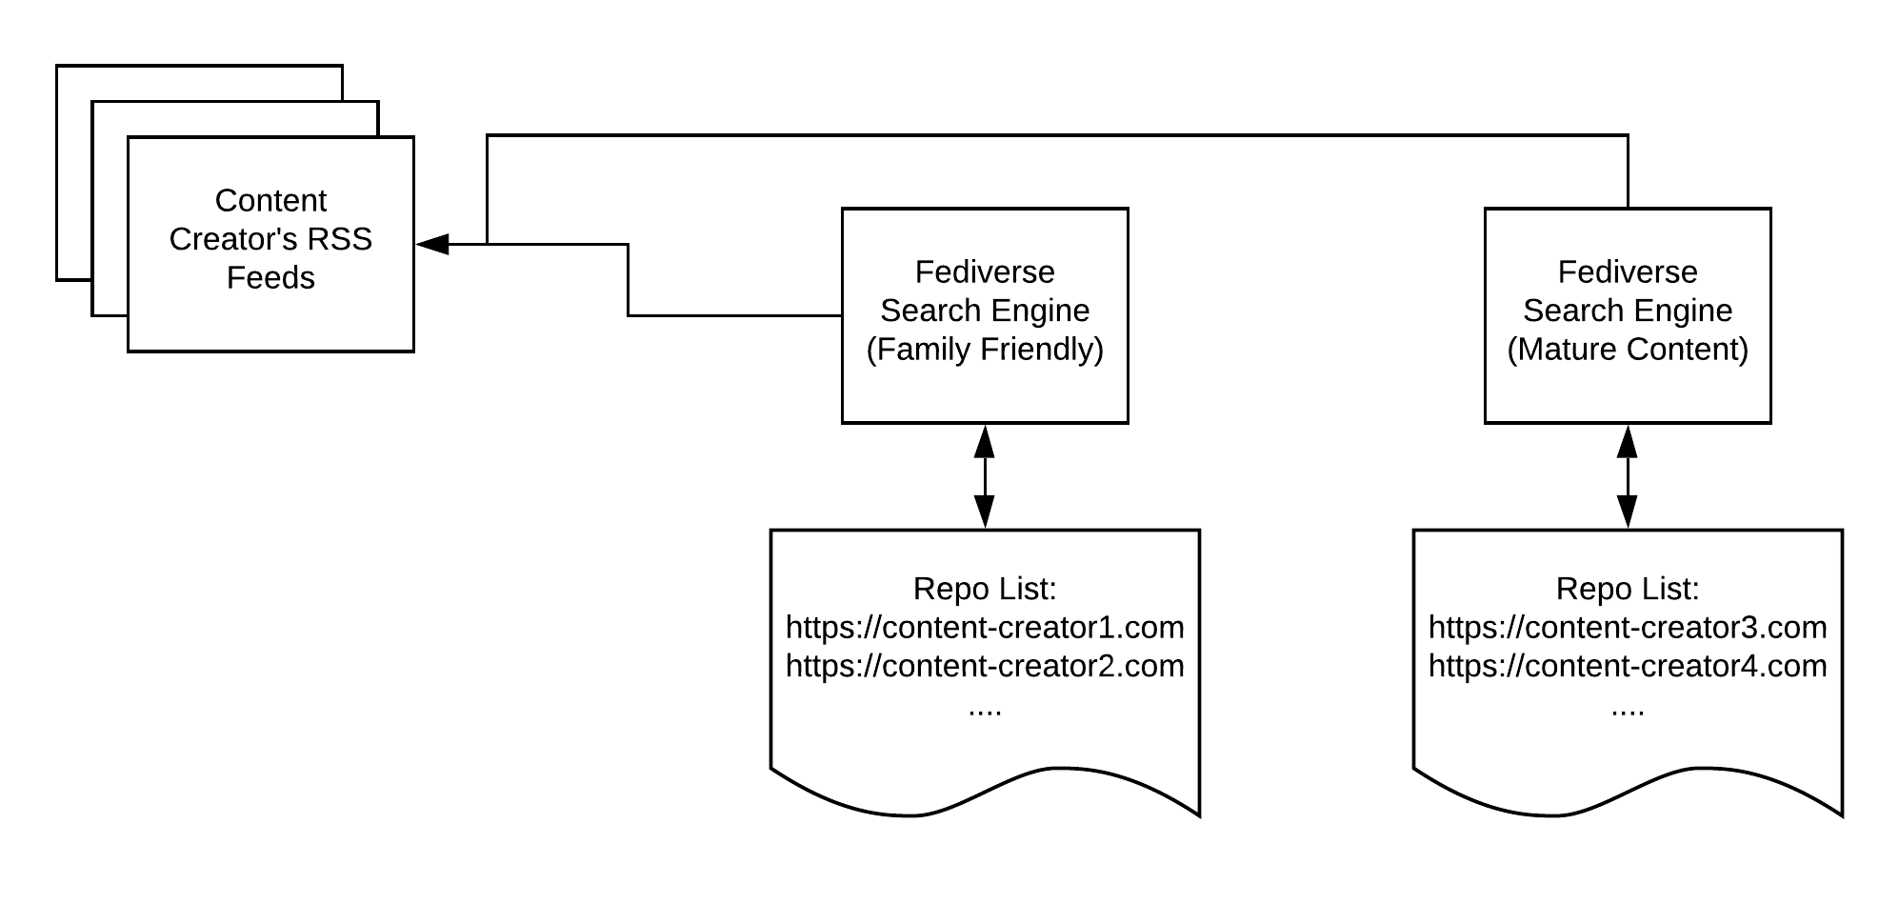
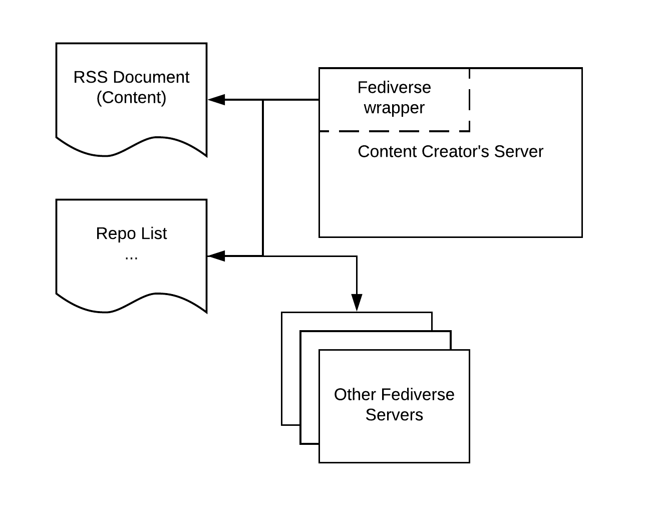
General Architecture Continued:
Here is what I can make sense of from the discussions earlier today.
Essentially, some form of generic application can be written called "Fediverse"
from there, that application can have a "Wrapper" that can be used to get installed anywhere from magento, wordpress, or any other integration
That binary, will process payments, and distribute RSS Feeds
Those RSS feeds can be consumed by any number of "Subscribers" who can index the content, the decide however they'd like to censor it (if even at all)
The "Subscribers" can be whole websites, or individual users that have their own RSS Clients
In addition, a content creator's server could then also consume those feeds and display it on their own site, such that any 1 content creator could advertise other content creator's content on their site, perhaps with a "kick back" for sending traffic to the other person.

This perhaps could be a "General Architecture" On what to build

Meeting 3
Decided on:
- NextCloud for document storage [Ben]
- Repo, backlog, dual track agile in Gitlab [Cory &

Meeting 4

Questions:
- What are we using for a virtual whiteboard?
- Are we paying for an IDE?
- What is the roadmap?
- Where are the team projects/repos?
- Do we have KPIs?
- What does success look like?
- What is our first outcome?
- Who is the main persona? Who are we targeting first?

